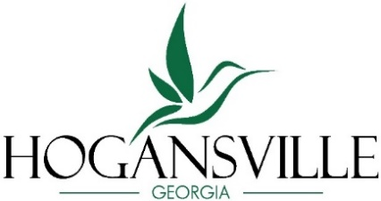
City of Hogansville
City Council
Regular Meeting Agenda

Monday April 20, 2026 – 7:00 pm_

Meeting will be held at Hogansville City Hall,
111 High Street, Hogansville, GA 30230
Mayor: Jake Ayers 2029 City Manager: Lisa E. Kelly
Council Post 1: Michael Taylor, Jr 2029 Assistant City Manager: Oasis Nichols
Council Post 2: Jason Baswell 2029 City Attorney: Alex Dixon
Council Post 3: Mandy Neese * 2027 Chief of Police: Jeffrey Sheppard
Council Post 4: Mark Ayers 2027 City Clerk: LeAnn Lehigh
Council Post 5: Kandis Strickland 2027 * Mayor Pro-Tem

REGULAR MEETING – 7:00 pm
1. Call to Order – Mayor Jake Ayers
2. Invocation & Pledge

CONSENT AGENDA
All items listed under the Consent Agenda are considered to be routine in nature and will be approved by one blanket motion.
- Approval of Agenda: Regular Meeting April 20, 2026
- Approval of Minutes: Work Session Meeting April 6, 2026
- Approval of Minutes: Regular Meeting April 6, 2026
PRESENTATION
- Employee Recognition – Lillian Drake – 15 Year Anniversary

NEW BUSINESS
- Ordinance – 1st Reading – Rezoning – Parcel No. 0023001016 – Weaver Tract
- Preliminary Plat Application – HillStar Ridge - Chisel Mill Design & Build LLC
- Hummingbird Hollow – Final Plat
- Bid Award – LCRR Water Line Determination & Replacement

CITY MANAGER’S REPORT

ASSISTANT CITY MANAGER’S REPORT

CHIEF OF POLICE REPORT

COUNCIL MEMBER REPORTS
- Council Member Ayers
- Council Member Strickland
- Council Member Taylor
Upcoming Dates & Events
- April 19-25, 2026 – GEORGIA CITIES WEEK
- April 22, 2026 – Community Clean Up, Tire Amnesty, Shred at Calvin Hipp Park Downtown Hogansville
- April 25, 2026 – Touch-A-Truck and Celebrate Recovery’s Annual Car Show – Downtown Hogansville
- May 4, 2026 – 7:00 pm | Regular Meeting of the Mayor and Council at Hogansville City Hall

- Council Member Baswell
- Council Member Neese

MAYOR’S REPORT

EXECUTIVE SESSION
- Real Estate Exemption

ADJOURN
The Royal Theater Happenings
- Saturday, April 25, 2026 – 7:30 pm |LIVE EVENT: One Night in Memphis
- Friday, May 1, 2026 – 7:00 pm |MOVIE: Caddyshack
- Friday, May 8, 2026 – 7:00 pm |MOVIE: Blue Collar Comedy Tour the Movie
- Saturday, May 9, 26 – 4:00 pm |MOVIE: Bambi
- Saturday, May 9, 26– 7:00 pm |MOVIE: Coal Miner’s Daughter
- Saturday, May 16, 2026 – 7:30 pm |LIVE EVENT: Boomer Broads

Purchase tickets online 1937royaltheater.org or call the box office 706-955-4870

